`IntelliPEN – a digital pen & USB Drive

- The IntelliPen Receiver has a clip attached and a removable end which hides the USB attachment

- The IntelliPen Receiver has two GREY half moon shapes on the surface

- Left half moon is ON / OFF
- Right half moon is PAUSE

- You will notice three icons in between these half moons

- Receiver Ø
This will light up when ON
This will blink when the receiver is being charged via the USB port on your computer

- Pen ⁄
This will light up when RECORDING handwriting
This will blink when pen battery is low
(Please inform DSS if battery is low)

- Receiver battery ▓
This will blink when receiver battery is low.
There will be 10minutes of handwriting time left before it shuts down

Starting to Write

- Clip the receiver in the CENTRE of a blank page
- Make sure it is firmly in place
- Do not have any objects in front of the receiver

- Press the Ø receiver button and wait until the Ø STOPS flashing

- Start using the IntelliPen to write your notes

- As you write keep your fingers AWAY from crystal cone at the lowest part of pen. The cone is the clear plastic around the nib of the pen

- Use the PAUSE switch when not writing! This will give you more writing time

- Avoid writing on uneven surfaces!

Using the Software

What the software can do:
- Changes handwriting into text
- Converts document into PDF file
- Edit and convert documents
- Send as email
- Save in various formats
- Navigate through pages
- Save onto memory stick

Convert and Edit Handwritten notes into TEXT

- Go into computer and Open Pen and Ink Editor in Programs
- Take IntelliPen receiver and remove left hand corner cover
- Insert IntelliPen receiver into USB port on computer
- Open File in Menu Bar
- Click on Open
- Click on My Notes
- Choose correct document. It will end in .eli (file default)
- Open
- You will now see your written notes created by the IntelliPen
- Choose EDIT from drop down menu bar and click
- Choose CONVERT TO TEXT from drop down menu bar and click
- Wait a few seconds
- You will now see your notes are in typed text
- Save this document onto your memory stick. File will default to .ant

- IMPORTANT: Delete your work from the IntelliPen device!

- Safely remove device from computer
- Turn Device OFF

How to load the IntelliPen PEN & INK software

- The software is loaded onto the DSS laptops and also the stand alone DSS computers in the libraries
- If the software is not loaded you can ring the DSS or speak to a librarian.
- You can load it yourself

To Begin
- Put the MINI disk into the disk drive (no need to use larger disk)
- Go into Explorer
- Go into D:drive
- Double click on SETUP.EXE (this looks like a green sun icon)
- Follow prompts for Preparing To Install – the wizard
- This will take a few minutes to start, please be patient
- Click on NEXT when asked
- Agree to all including License
- Tick Typical when given a choice and Next
- Keep following Wizard commands and agree to all

IMPORTANT

- At this point (see image below) You need to Install Digital Pen & USB Flash Drive Software. AND DOWNLOAD and Install Microsoft Tablet PC Recognizer 2005. Click on the link. You will be taken to internet site. Click on DOWNLOAD. This will take a few minutes. (please see next image)

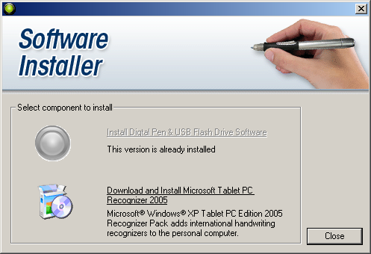
- The next thing to happen is this screen

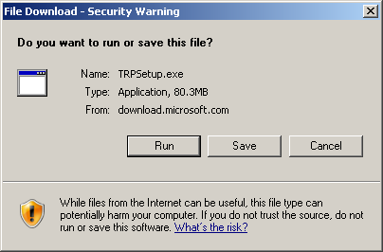

- Click on Run and agree to all.

- You have now loaded the software onto your computer.
- Well done.

- All your handwritten notes can now be successfully changed into typed text.

