Echo smart pen
I Pen
I booklet of livescribe dot paper
I pencil case

To Begin

- Take pen, cable and booklet out of pencil case
- Have booklet open at a blank page
- Pen has an icon Φ and a clear view panel at one end
- Press icon to start pen
- The pen will show Starting in view panel
- The pen is ready to use when the time is showing
- Take the nib cover off. This is quite small and easy to lose so place in pencil case!
- Notice the ICONS at the bottom of the booklet page.

• a large dot for Record
ll a double bar for Pause
- a square for Stop

- With the nib cover removed TAP the nib on the Record dot
You will hear a bell sound
- Begin to write your notes
- These can be in dot point as the lecture/class is now being recorded
- To Stop recording Tap the nib on the small square
You will hear a different bell sound
- To Pause Tap the nib on the double bars
- Every time you begin writing Tap the nib on the Record dot

Hearing what you wrote

- Anywhere in your notes tap the nib on the writing
- You will hear what was being said by the lecturer at that stage of class
- You may notice some scratching sounds, that is the pen writing on paper!
- To Stop the recording, tap pen on the Stop square at bottom of page.
When finished Turn Pen Off by pressing the icon Φ
- Place nib cover on pen

If icon Φ has a plug showing with a battery and is flashing it needs to be charged

To Charge Pen

- Place the connect cable into the tiny USB port on pen
- Place other end of cable into computer USB port
- The Pen will now start to charge: a full charge can take 2.5 hours
Please inform DSS or library if Pen is not charged
Paper: please inform DSS if you need livescribe Dot Paper
Using the LiveScribe Software with this Pen (Software is loaded on all DSS computers)
Available from www.livescribe.com/install

- Listen to Audio file (excellent clarity)
- Read your notes whilst listening
- Send your notes and or audio to Email / Facebook / Mobile
- Save your notes
- Organise and manage your notes

Go to Programs

- Open Livescribe
- Plug Pen into USB port via cable
- Click on Navigation in Menu Bar
- You will see Pages icon and Audio icon below Menu Bar

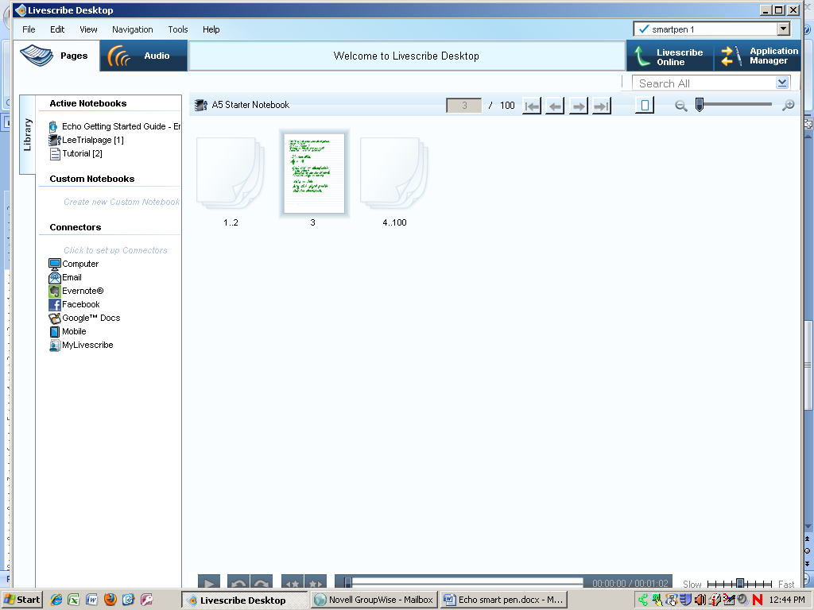

To View Notes and Print them

- Click on PAGES icon
- Under Active Notebooks click on A5 Starter Notebook
- You can rename your notebook
- Right click mouse on notebook title and choose Rename
- Type your chosen notebook name e.g. Lee Trial Page

- You will see pages displayed on right side of screen
- Double C lick on your page: it will now open in a full screen
- You can print this page
- In Menu bar chose File
- Click on Print and follow prompt

To hear the Audio of lecture

- Click on Audio icon (under Menu bar)
- Choose the correct file
  - There are page icons beside the files with note pages
- Double click on a page icon
- Audio recording will start and you will see the page with writing

- Stop, Pause, Forward are at bottom of screen Far Left
- Slow and Fast are at bottom of screen Far Right

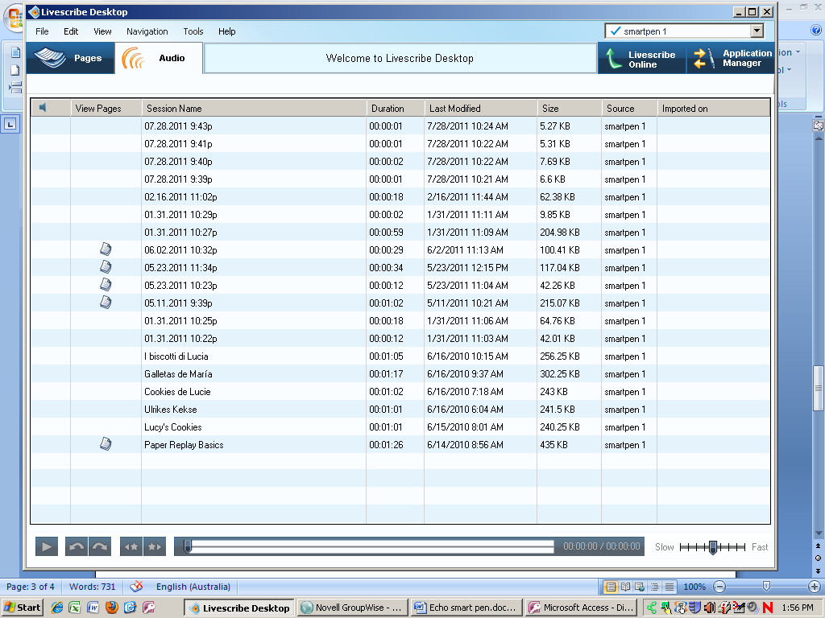

To Send Pages

- On Far Left Hand Side of you will see two file tabs SESSION and LIBRARY
- Session tab shows
Pages
- Library tab shows
Computer
Email
Evernotes
Facebook
Google Docs
Mobile

- Select Email
- Follow prompts
- Click on address and fill out details
- Hit SYNCH now
- With cursor on PAGE (your handwritten notes)
- Right click mouse
- Go to SEND PAGE (3 etc) to….
- Choose EMAIL or Mobile or Facebook etc
- Click mouse
- Select Pages with Audio or Pages Only or Audio Only
- Click Continue
- An Email Screen will pop up
- Fill out address and Send
- This is useful to send your own notes and audio files to your home computer

DELETE ALL FILES ONCE SAVED! Other students will be using this device

To Delete both Notebook and Audio files

- Highlight your Notebook e.g LeeTrialPage
- In File Menu choose ARCHIVE NOTEBOOK
- Click Archive Notebook
- Click OK
- Click Archive
- Under LIBRARY file tab (Far right side of screen) you will see ARCHIVED NOTEBOOKS
- Your notebook will be listed there
- Place cursor on your notebook name and Right click mouses
- Choose Delete Notebook – you should have either saved or sent this BEFORE you delete
- Yes to Delete Notebook AND Audio files
- Delete
- Your Notebook has now been deleted along with Audio files

Turn Pen OFF
Log Off

