

Disabled Equity Action Plan
2025-2028

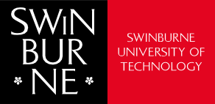
Swinburne.edu.au

Contents

Acknowledgement of country ii
Message from the Swinburne Association for Accessibility (SAFA) iii
Message from the Swinburne Accessibility Network (SAN) iv
Our roadmap to disability inclusion v
A note on disability vi
Key focus areas 1
1. Leadership and commitment 2
2. Student experience 6
3. Employee experience 9
4. Our built environment 12
5. Digital environment 14

Acknowledgement of country


We respectfully acknowledge the Wurundjeri People of the Kulin Nation, who are the Traditional Owners of the land on which Swinburne’s Australian campuses are located in Melbourne’s east and outer-east, and pay our respects to elders past and present.

We are honoured to recognise our connection to Wurundjeri Country, history, culture, and spirituality through these locations, and strive to ensure that we operate in a manner that respects and honours the Elders and Ancestors of these lands.

We also respectfully acknowledge Swinburne’s Aboriginal and Torres Strait Islander staff, students, alumni, partners, and visitors.

We also acknowledge and respect the Traditional Owners of lands across Australia, their Elders, Ancestors, cultures, and heritage, and recognise the continuing sovereignties of all Aboriginal and Torres Strait Islander Nations.

Message from the Swinburne Association for Accessibility (SAFA)
The Disabled Equity Action Plan is an encouraging foundation and important step toward building a more inclusive and equitable Swinburne for all students and staff that prioritises the progression of disabled equity, authority and leadership. It highlights the power of collaboration and the importance of listening to the disabled community in shaping the future of our university.

This plan places our perspectives—both from students and staff—at the heart of meaningful change. It’s not just about making space; it’s about transforming systems and structures so that everyone feels genuinely included, respected, and empowered to be present and thrive. The DEAP moves us beyond the idea of simply “tolerating” difference. Instead,
it pushes for real acceptance and celebrates the value that diversity brings to our learning and working environments. It’s
a reminder that this isn’t just a goal—it’s a shared responsibility.

I’m looking forward to seeing how this plan unfolds and how student voices will continue to shape Swinburne’s journey toward genuine inclusion. As we make progress, I hope to see our targets evolve in our collective effort to strive for higher standards that align with our values and expectations. Let’s stay engaged, speak up, and support each other as we work toward a campus and community where everyone can thrive.

Erin Mayall
Chair
Swinburne Association for Accessibility (SAFA)

Message from the Swinburne Accessibility Network (SAN)
The DEAP has been developed through close collaboration with the Swinburne Accessibility Network (SAN). This network includes both a staff branch and a student-led branch known as the Swinburne Association for Accessibility (SAFA).

By choosing the term Disabled Equity, SAN aims to ensure that disability is not sidelined or minimised. We intentionally moved away from the term accessibility because it is often understood as solely related to physical access, which overlooks the deeper cultural and systemic barriers faced by people with disability.
Additionally, accessibility can serve as a euphemism, avoiding the word disability entirely.

With 21.4% of Australians identifying as disabled, it is essential that these experiences are not overlooked. The DEAP works towards embedding disability equity into our systems, ensuring that disabled people are fully included, supported, and heard, with dignity and respect.

Words matter. The acronym DEAP was chosen not only because it resonates with the word deep, symbolising lasting changes this plan aims to achieve, but also because it represents a commitment to a comprehensive, foundational approach
to inclusion. The actions outlined in this plan are intended to reach into the very core of our university, including our culture, systems, and decision-making frameworks, to build a truly inclusive and equitable environment for all.

As Staff Chair of the Swinburne Accessibility Network, I am proud that this plan has been shaped by our community’s voices and lived experiences. DEAP is people-centred, values-driven, and forward-thinking. It marks a shift from compliance to genuine transformation. It is a collective commitment to a university where disabled staff and students are included, supported, respected, and empowered to reach their full potential.

Lauren Carter
Chair
Swinburne Accessibility Network (SAN)

Our roadmap to disability inclusion

Swinburne is proud to launch our Disabled Equity Action Plan 2025-28 — our university’s roadmap for building a safe, supportive, and accessible environment for people with disability.

As Executive Co-Sponsors for Disability Inclusion,
we are committed to ensuring that disability inclusion is not just a principle, but a lived reality across our university. This plan outlines our shared responsibility to eliminate barriers to participation, challenge assumptions on disability, and embed inclusive practices in our learning and working environments.

Inclusion is not the work of a few but a collective effort. We therefore call on every member of our community, senior executives, people leaders, staff, and students, to actively contribute to this cultural shift.

Prof. Simon Ridings
Senior Deputy Vice-Chancellor and Chief Academic Officer Executive Co-Sponsors for Disability Inclusion

Prof. Laura-Anne Bull
Deputy Vice-Chancellor (Education, Experience, and Employability) Executive Co-Sponsors for Disability Inclusion
At Swinburne, we are continually striving to be a more diverse and more inclusive university, to welcome and support everyone to engage in tertiary education.

Our university’s founders, George and Ethel Swinburne, were passionate about the importance of equal opportunity for all, regardless of background or circumstance. Their belief in access and equity continues to guide us today.

This plan marks an important step forward in our journey. As a university that brings people and technology together to build a better world, I am proud of the innovative ideas and actions within that are designed to drive transformative change and foster a deeper sense of belonging for students and staff with disability.

We remain committed to listening, learning and evolving so that Swinburne is always a place where everyone feels valued, supported and empowered to succeed.

Prof. Pascale Quester
President and Vice-Chancellor

A note on disability

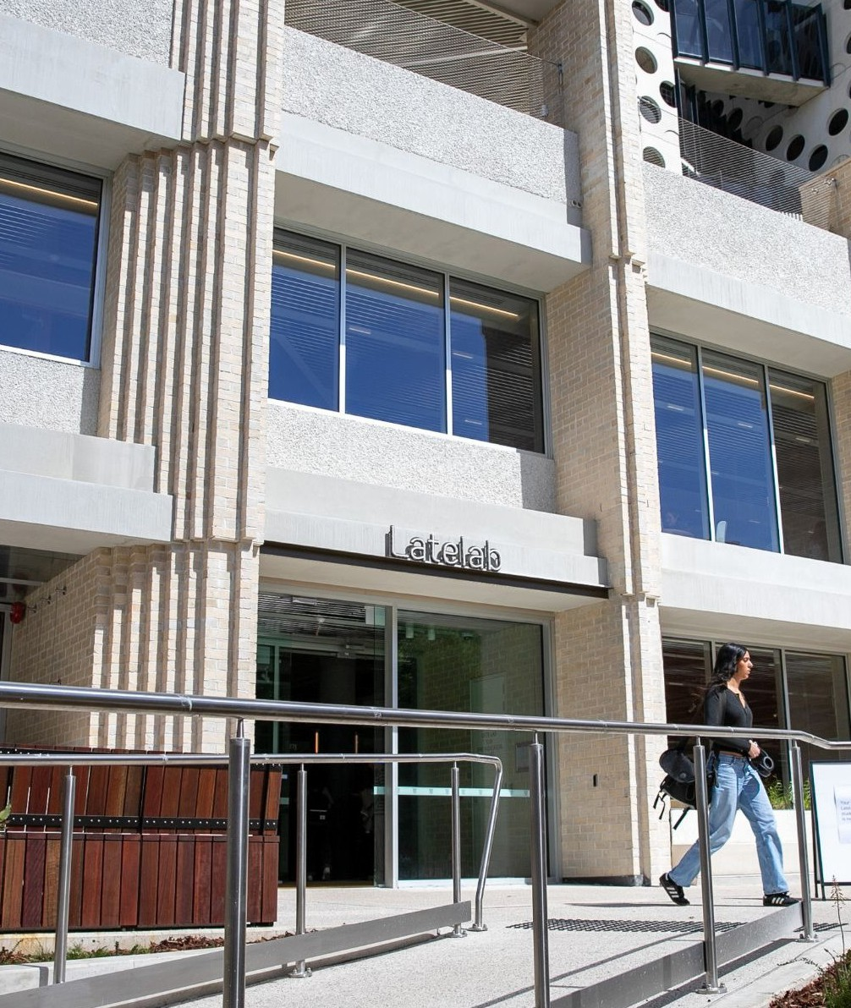
Disability occurs when a person with a long-term physical, psychosocial, neurological, intellectual, or sensory condition is met with societal barriers that prevent them from participating on an equal basis with non-disabled people. *

This definition reflects the social model of disability, which recognises that disability is created not by the condition itself, but by environments, systems, and attitudes that are inaccessible or exclusionary.

We acknowledge and respect that people have different preferences when it comes to language. The DEAP uses both identity-first (e.g., disabled person) and person-first (e.g., person with disability) language to reflect the diversity of perspectives within the disabled community.

Swinburne is legally obligated to comply with the Disability Discrimination Act 1992 and the Disability Standards for Education 2005. These frameworks require educational institutions like ours to ensure that students and staff with disability can participate on an equal basis with others, including through reasonable adjustments in education and employment settings.

Grounded in the principles of equity, respect, and empowerment, the DEAP reaffirms our commitment to the meaningful inclusion of people with disability. It aims to break down attitudinal, systemic, and environmental barriers, ensuring that individuals with disability are supported, valued, and empowered to thrive.

*Adapted from the United Nations’ Convention on the Rights of Persons with Disabilities

DEAP

The Swinburne Disabled Equity Action Plan (DEAP) 2025-28 has five key focus areas:

Leadership Commitment– Swinburne leaders are committed to increasing the university’s disability confidence by implementing the DEAP, ensuring that our policies and processes are inclusive of people with disability, partnering with the Swinburne Accessibility Network and Swinburne Association for Accessibility to increase a sense of belonging for staff and students with disability at Swinburne.

Student Experience – We continue to attract talented students from around the globe with diverse backgrounds and experience and ensure equity for students living with disability throughout the student lifecycle. Support for students with disability is promoted and resourced to enable them to achieve their full potential.

Employee Experience – We continue to attract and retain talented people with diverse backgrounds and experience to our workplace, including people with disability. We strive to make our workplace inclusive, equitable and accessible.

Built Environment – Our built environments continue to meet our legislative requirements for accessibility for staff, students, and visitors. We will continue to embed inclusive design and accessibility in design standards for new buildings, renovations and major works.

Digital Environment – We will embrace technological innovations to enhance accessibility and inclusion and continue working towards Swinburne’s vision of people and technology working together to create a better world.

We acknowledge and respect that people have different preferences when it comes to language. This Action Plan uses both identity-first (e.g., disabled person) and person-first (e.g., person with disability) language to reflect the diversity of perspectives within the disabled community.

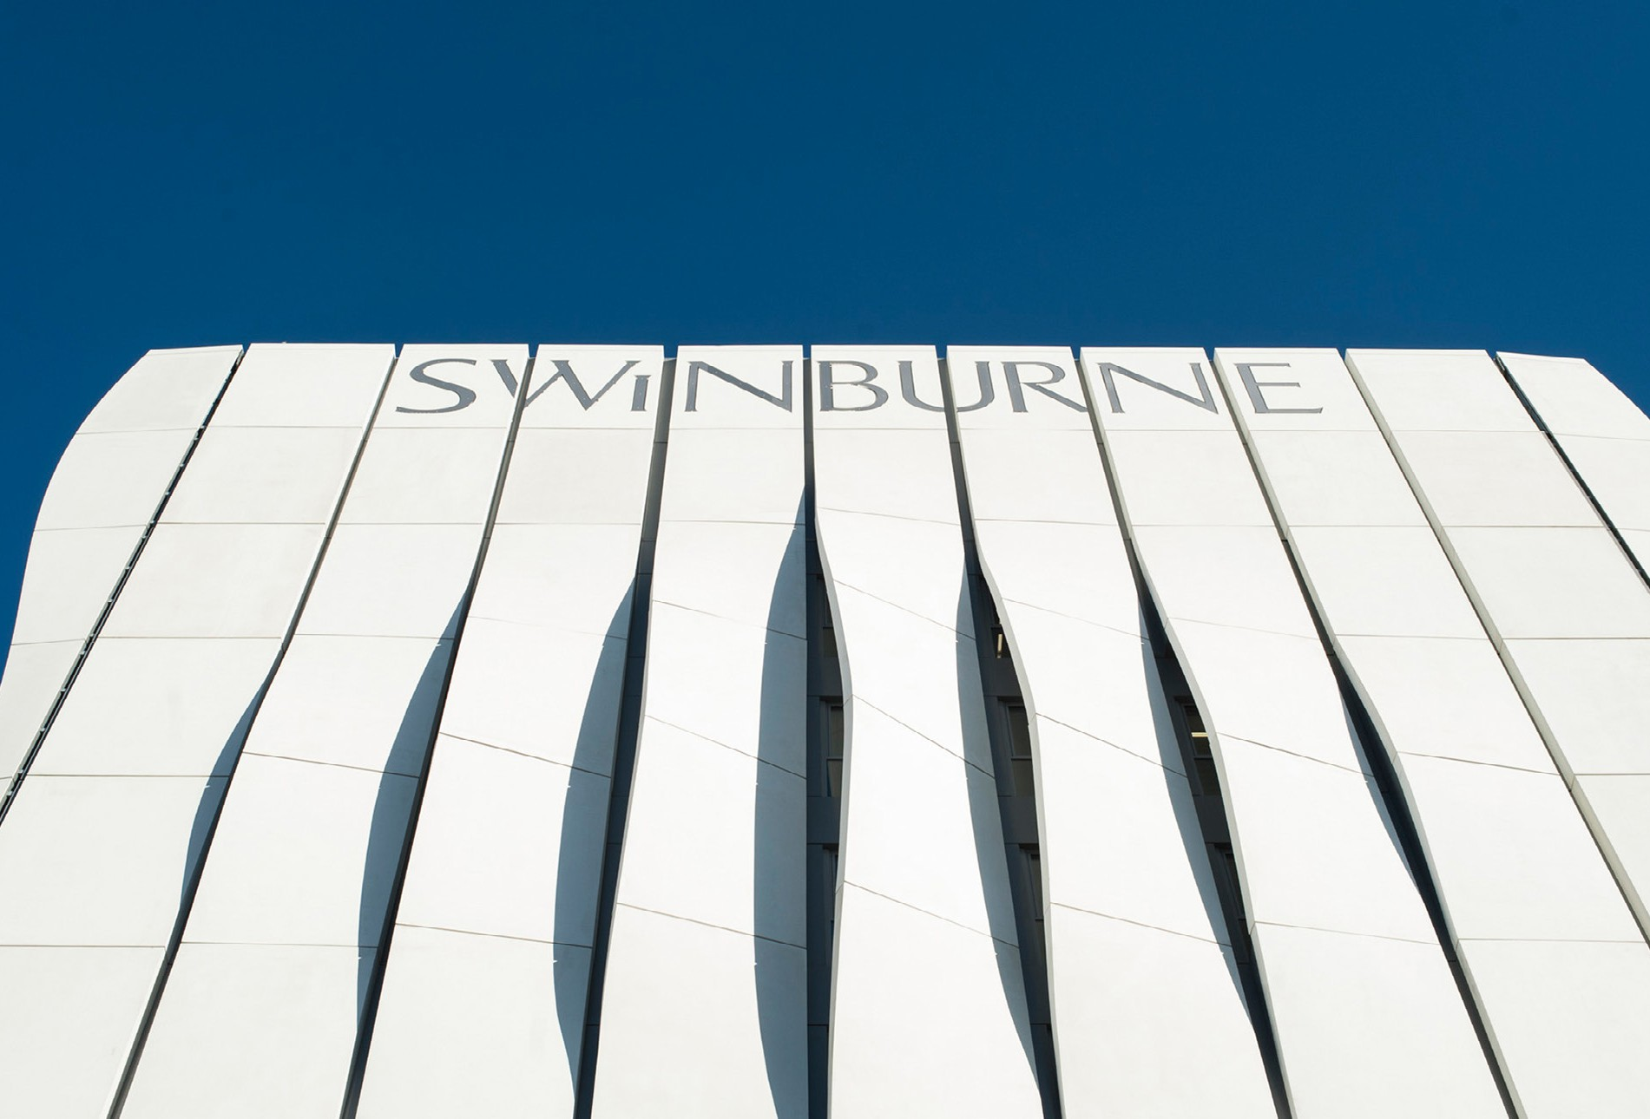
Goal: To build a positive, accessible, and inclusive learning community for staff and students with disability.

Aim:

  - The University’s commitment to the DEAP 2025-28 is established at an executive level

Actions:

    - Identify a University Executive to be the Accessibility Champion for the DEAP 2025-28

Success Measures:

Accessibility Executive Champions appointed and active.
Timing: Completed 2024 Accountability:
Approval: DISC

Action: DE&I

Aim:

  - The implementation and reporting of our DEAP is embedded as business as usual (BAU)

Actions:

    - Confirm Leadership across key functional areas to drive the implementation of DEAP Actions.
    - Provide biannual reports to the Diversity and Inclusion Steering Committee (DISC) on the DEAP’s implementation, progress, and any outstanding matters.

Success Measures:

Functional leads confirmed.

DEAP integrated into university governance structures. DEAP progress is reported to DISC twice a year.

Timing:

Commencing 2025

Accountability: Approval: DISC Action: DE&I

Aim:

  - Our community is aware of and empowered to contribute to the DEAP

Actions:

    - Empower staff and student accessibility networks to provide feedback and recommendations regarding strategies, policies, and projects.

Success Measures:

Swinburne Accessibility Network recognised as key stakeholder in matters concerning accessibility across the university.

Timing:

Ongoing

Accountability:

Approval: DISC

Action: Executive Champions and DE&I

Aim:

  - Swinburne is promoted as an accessible, equitable and inclusive environment at all levels

Actions:

    - Our stakeholders and broader community are appropriately informed and engaged in the rollout of the key actions in the DEAP.
    - The achievements of our staff and students living with disability are promoted and celebrated.

Success Measures:

Communications Plan developed implemented and maintained. Media content featuring staff and students living with disability are widely circulated
Timing: Commencing 2025

Accountability:
Approval: DVC External Engagement

Action: Director, Communications and Media

Aim:

  - Marketing, communications, and events reflect the diversity of the
Swinburne community

Actions:

    - Review existing marketing, communications, and events protocols, practices, and guidelines against best practice in accessibility, and update as required.
    - Ensure disability is affirmatively promoted through appropriate, positive language and imagery, and integrated into approval processes.

Success Measures:

Marketing communications, and events guidelines, protocols, and practices are reviewed and benchmarked against best practice in accessibility

Timing:

Commencing 2025

Accountability:

Approval: DVC External Engagement

Action: Director, Communications and Media

Aim:

  - The accessibility of our communications, marketing, and events continuously improves and evolves in line with best practice

Actions:

    - Continue to update existing accessibility guidelines to enhance the toolkits available for the creation of accessible content.
    - Update the web-based Complaints and Feedback Form to provide a phone number and email address and include a field for users to identify their preferred method of communication.

Success Measures:

Evidence of improved accessibility of communications, marketing and events.
Web-based complaints and feedback form updated
Timing: Commencing 2025

Accountability:
Approval: DVC External Engagement

Action: Director, Communications and Media


Goal: Support for students with disability is promoted and resourced to enable them to achieve their full potential.

Aim:

  - Swinburne’s learning and teaching resources are accessible, and students are supported in their transition/progression.

Timing:

Commencing 2025

Actions:

    - Audit learning and teaching resources to ensure they meet accessibility requirements, with a specific focus on the accessibility of captioning and image description practices for digital resources.
    - Develop easy-to-read or plain language resources and learning materials.

    - Review the provision of audio captioning to ensure automated and human captioning are correctly employed in the appropriate contexts.

Success Measures:

Audit of sample of learning and teaching resources confirms it meets accessibility requirements. Material that does not meet accessibility requirements is modified.

Accountability:

Approval: DVC EEE

Action: PVC Educational Innovation

Aim:

  - Students living with disability receive the best support and educational experience possible.

Timing:

Commencing 2025

Actions:

    - Undertake a full review of the end-to-end process for students
self-identifying at point of enrolment, those registered with AccessAbility and in receipt of an Educational Access Plan (EAP), and understand
the pain points students, educators and placement providers face and implement improvements.
    - Establish a continuous improvement loop for EAP provision which includes data from a range of touchpoints: point of enrollment, the EAP consultation and approval process, implementation of timelines, management, and implementation of EAPs and feedback from students on the efficacy of the adjustments implemented.
    - Implement measures and effective referral protocols to ensure students receive a joined-up holistic educational experience

Success Measures:

Review completed with recommendations and detailed costings for improvements available end of 2025.
Continuous improvement process articulated and implemented with agreed reporting cycle established.
Effective referral protocols in place.

Accountability:

Approval: DVC EEE

Action: Director, Student Experience

Aim:

  - Inherent Requirements, entry requirements and other required expectations are clearly identified for all courses and professional/work placement settings and available to students.

Actions:

    - Establish a working party to review resources available for staff and students, develop policy and determine workflow processes and staff responsible in relation to Inherent requirements of WIL and reasonable adjustments for WIL.
    - Ensure the Informed Choice (IC) documents are developed for all courses and that they provide clear information regarding:
      - the Inherent Requirements of courses and industry standards,
      - details of Inherent Requirements of WIL and available reasonable adjustments for WIL,
      - pathways available for students who fail to meet Inherent Requirements.

    - Review processes and resources to ensure Inherent Requirements are used at key points in their student journey.

Success Measures:

Working party established with terms of reference and identified expected outcomes.

AccessAbility Advisors and Employability team use Informed Choice documents to make determinations of reasonable adjustments in courses and placement settings.
Students are supported to self-advocate for themselves and use strength-based approach to disclosure informed by course and industry expectations.
Inherent Requirement processes are documented, and staff are trained to implement them at key stage in the journey.

Timing:

Commencing 2024

Accountability:

Approval: DVC EEE

Action: Director, Student Engagement Action: Director, Student Engagement

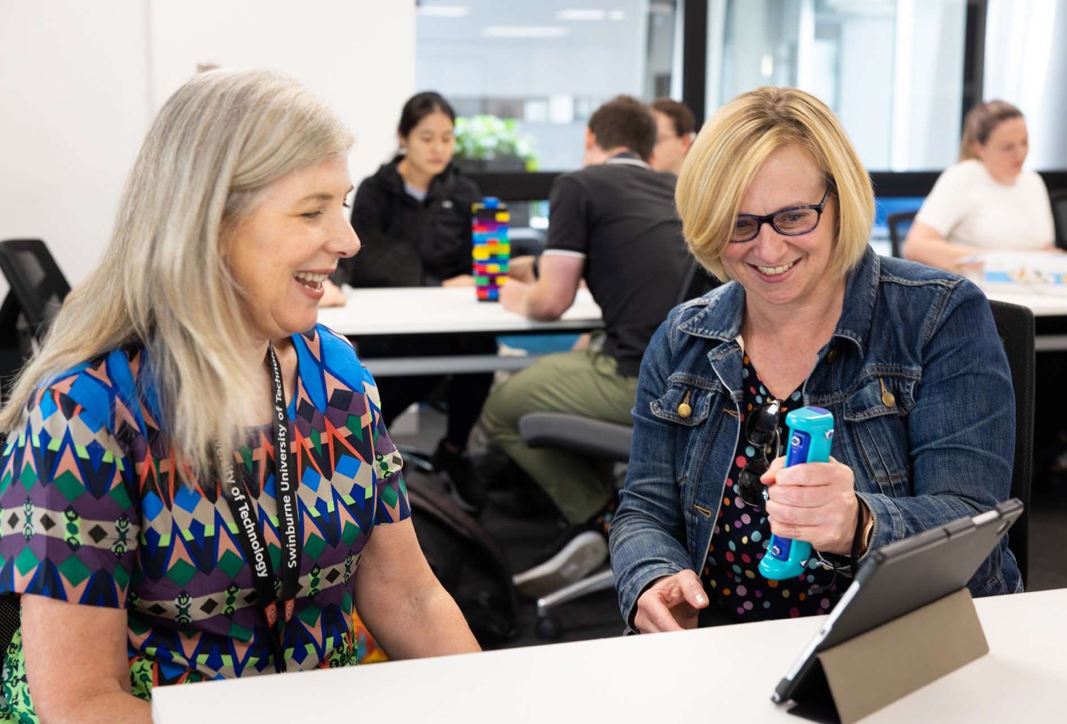
Goal: We will strive to make our workplace more inclusive by providing equitable access to employment and career development opportunities.

Aim:

  - Recruitment processes are accessible, equitable, inclusive and attractive to candidates with disability.

Timing:

Commenced in 2024

Actions:

    - Participate in the Australian Disability Network (ADN) Confident Recruiter program to review and improve accessibility of recruitment and onboarding processes.
    - Include a broad statement regarding Swinburne’s commitment to employing and supporting the career development of people living with disability on Swinburne’s external web pages and ensure DEAP is publicly available.
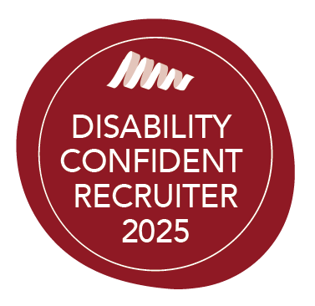

Success Measures:

Recruitment process reviewed against best practice, and inclusive recruitment guidelines and processes created in collaboration with the Swinburne Accessibility Network.
Statement on commitment to employing people living with disability in place with link to Accessibility Action Plan and clear contact details for further support.
Awarded Disability Confident Recruiter status.

Accountability:

Approval: Chief People Officer

Action: Director, Talent, Organisational Development and Remuneration

Aim:

  - Swinburne employees and leaders are skilled in fostering an accessible, equitable and inclusive workplace.

Timing:

Commencing 2025

Actions:

    - Update ‘Working Together’ training module to include disability equity, inclusion and confidence content.
    - Embed inclusive leadership capability into our leadership programs, ensuring that leaders understand individual needs and provide necessary adjustments to create an equitable workplace in which everyone can thrive.

Success Measures:

‘Working Together’ Compliance training module updated with 100% completion.

Employee satisfaction with support from their manager is maintained at >84% for those who identify as living with disability in staff engagement surveys.
Evaluation of training includes measurement of increased knowledge and application in the workplace.
Employees living with disability report an increased sense of belonging in the staff engagement survey from 46% to 62%.

Accountability:

Approval: Chief People Officer

Action: Director, Talent, Organisational Development and Remuneration

Aim:

  - Barriers to workplace participation are resolved; Swinburne actively pursues measures to ensure equitable access to its workplace.

Timing:

Commencing 2025

Actions:

    - Develop Workplace Adjustment guidelines and update current procedures to include adjustments for career development opportunities.
    - Provide guidance to people leaders on their role and responsibility in supporting reasonable workplace adjustments.
    - Promote and share information about Job Access for teams and
managers responding to requests for workplace adjustments.

Success Measures:

Workplace Adjustment guidelines developed in collaboration with Swinburne Accessibility Network.
Positive feedback from employees on their level of satisfaction with the process, adjustments, manager support and time frames relevant to workplace accessibility, including adjustments/accommodations.
Employee satisfaction with the provision of career development opportunities increases from 32% to 51% and Flexible Work Arrangements is maintained
at >84% for those who identify as living with disability or have caring responsibilities in staff engagement surveys.

Accountability:

Approval: Chief People Officer

Action: Director, Talent, Organisational Development and Remuneration; and Director, Health, Safety and Wellbeing

Goal: We continue to improve access and the experience of our built environment for staff and students living with disability

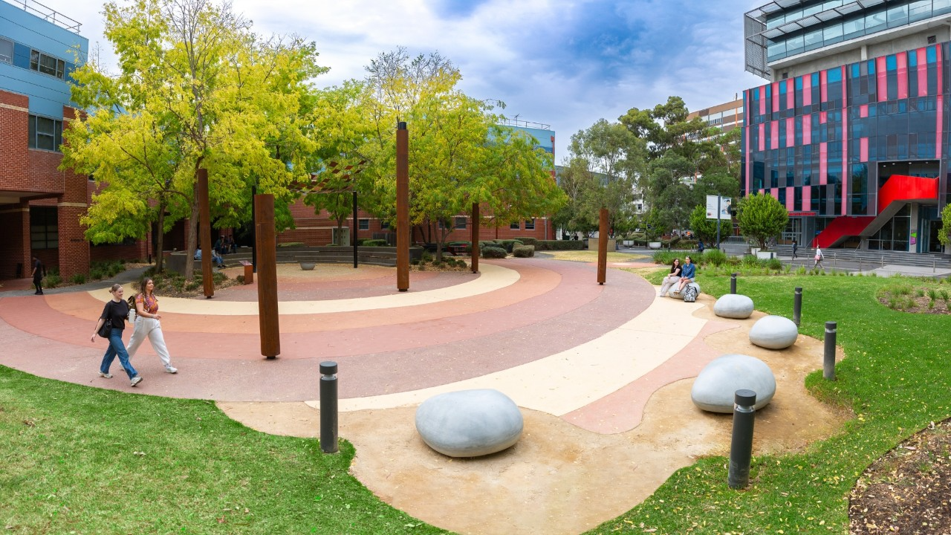

Aim:

  - Best practice in accessibility design for new projects and renovations.

Actions:

    - Maintain commitment to embedding inclusive design and accessibility in design standards for new buildings, renovations and major works. Examples are the inclusion of Swinburne Accessibility Network in the design and approval phase of the late lab which focused on equal experience, key sight lines and universal access to all indoor and outside areas.
    - Include information about accessibility considerations and improvements as part of communications on progress in the Facilities, Assets and Campus Services (FACS) community updates.
    - Communicate progress of the wayfinding project including the delivery of clear signage and digital wayfinding app.

Success Measures:

New buildings, renovations and major works are compliant, and adjustments are made where required to ensure accessible and inclusivity for people living with disability.
Swinburne Accessibility Network and Swinburne Association for Accessibility are included in available opportunities to co-create spaces.
All staff and students are informed of projects and building works that will improve accessibility at our campuses.
Outcomes of the wayfinding project are communicated across campus.

Timing:

Commencing 2025

Accountability:

Approval: Chief Operating Officer

Action: Director of Campus Assets, Facilities, and Sustainability; Director of Property, Space & Infrastructure Projects

Aim:

  - Students and staff living with disability can work and study safely and effectively in on-campus spaces.

Timing:

Commencing 2025

Actions:

    - Collaborate across the University to identify options for sensory-safe spaces across all campuses and develop these spaces, monitoring use and effectiveness in consideration of future planning and roll outs.

Success Measures:

Proposal developed in collaboration with staff & students, with costings, for introduction of sensory-safe spaces as required.

Accountability:

Approval: Chief Operating Officer

Action: Director of Campus Assets, Facilities, and Sustainability; Director of Property, Space & Infrastructure Projects


Goal: Consideration of access to our platforms, systems, and digital environments is embedded into our digital and data transformation strategy

Aim:

  - Platforms, systems and digital environments continue to evolve in line with leading practice in digital accessibility and universal design for learning.

Timing:

Commencing 2025

Actions:

    - Integrate consideration of accessibility requirements for procurement and development of software, digital resources and platforms.
    - Add a statement to the website advising of retro updating of old content and provide contact information (phone number and email address) to allow people to get in touch if they are unable to access content.

Success Measures:

Evidence of accessibility criteria being a consideration in the selection decisions for new digital systems and platforms.

Accountability:

Approval: Chief Operating Officer Action: Chief Information Officer

Aim:

  - Embrace technological innovations to enhance accessibility and inclusion.

Actions:

    - Embed consideration of inclusive design principles in Swinburne’s digital and data transformation strategy.
    - Identify mechanisms to stay abreast with new ICT developments relating to accessibility.

Success Measures:

Evidence of consideration of inclusive design embedded in transformational work.

Timing:

Commencing 2025

Accountability:

Approval: Chief Operating Officer Action: Chief Information Officer






Swinburne University of Technology
Swinburne.edu.au

General Enquiries
+61 3 9214 8000

Hawthorn Campus
John Street, Hawthorn Victoria 3122 Australia

The information in this report was correct at the time of publishing (August 2025).

ABN: 13 628 586 699
ISSN: 1477-8242
CRICOS provider code: 00111D
RTO 3059
TEQSA PRV12148 Australian University
X.com/swinburne facebook.com/swinburneuniversityoftechnology youtube.com/user/swinburne instagram.com/swinburne linkedin.com/school/swinburne-university-of-technology

