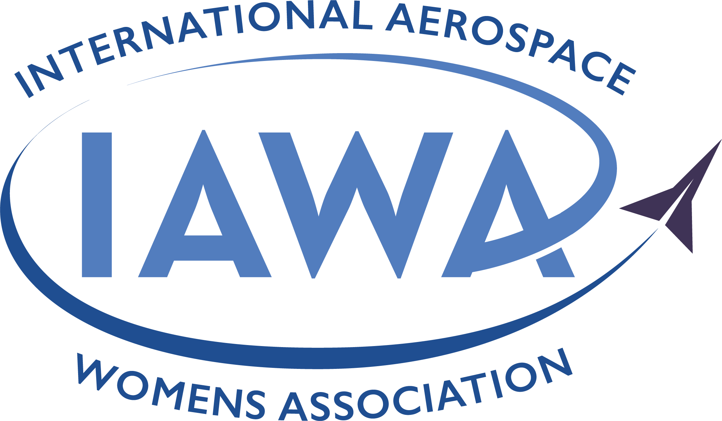
2026 IAWA SCHOLARSHIP APPLICATION OVERVIEW

IAWA’s Mission:

The International Aerospace Womens Association (IAWA) is an international organization for women who hold positions of impact in the aviation and aerospace industry. Founded in 1988, IAWA brings together women of achievement and promotes their advancement throughout the world. Its mission is to cultivate and advance women leaders in the aviation and aerospace industries through a global network.

IAWA Scholarship Purpose:

IAWA partners with eight (8) colleges and universities around the globe (University Partners) to bring scholarship opportunities to young women studying aviation and aerospace based upon merit as presented in their completed applications and reviewed by the University Partner and IAWA Scholarship Committees. All University Partners distinguish their programs by not only focusing on academic excellence in the aviation industry, they also intentionally focus on advancing gender diversity of their students and faculty members through their recruitment and retention.

IAWA Scholarship for each University Partner includes at IAWA’s discretion:

Monetary funds based upon USD $5,000

Attendance to IAWA’s Annual Conference (including conference fee, airline ticket, hotel stay)

Conference support through the mentorship of an IAWA Board or Advisory Board Member

Free Student IAWA Membership for one year, which includes the ability to participate in IAWA’s Mentoring Program

Scholarship Selection Process, Timeline and Criteria:

Each candidate must submit all items listed in the 2026 IAWA SCHOLARSHIP APPLICATION COVERSHEET AND CHECKLIST

A scholarship selection committee, designated by the University Partner, will review applications and select not more than five (5) recipients to be submitted to IAWA for final decision. Timing for launching the process is based upon a mutually agreed upon timeline between IAWA and the University Partner at the beginning of each year.

The IAWA Scholarship Committee will review the completed applications provided by the University Partner and select at least one (1) scholarship recipient within 30 days of receipt. Upon selection, a member of the IAWA Scholarship Committee will inform the scholarship recipient(s) and University Partner of the selection.

2026 IAWA SCHOLARSHIP APPLICATION COVERSHEET AND CHECKLIST

Full Name: ___________________________________ Preferred First Name: _________________
E-Mail: __________________________________ Phone #: _____________________________
___________________________________________________________________________

Colleges/universities attended & degrees pursued / attained:
Date(s) School Degree Grade/GPA
_________ _________________________ _____________________________________ ______
_________ _________________________ _____________________________________ ______

Honors Achieved/Honor Societies: ______________________________________________________________
____________________________________________________________________________________________
____________________________________________________________________________________________

Extra-curricular Activities (Work, Volunteerism, Clubs, Offices Held): _______________________________
____________________________________________________________________________________________
____________________________________________________________________________________________

Financial Information:
1. Have you received any scholarships for the current academic year or next year? Yes ____ No ____
If Yes, please describe and list amounts: ________________________________________________________
_________________________________________________________________________________________
2. Do you currently receive any financial assistance from your parent(s), family, or spouse? Yes ____ No ____
If Yes, please describe and list amount: _________________________________________________________
3. Do you currently receive any financial aid (student loans /government loans)? Yes ____ No ____
If Yes, please describe and list amount: _________________________________________________________
4. What amount of financial aid do you expect to receive in 2026-2027? _________________________________
5. List income you have earned or expect to earn (part-time jobs, summer employment, internships, etc):
2025: ________________ 2026: ________________ 2027: ________________
6. Are you interested in attending IAWA Annual conference and forums in person? Yes ____ No ____
7. If you are a Scholarship Recipient, are you comfortable traveling internationally alone? Yes ____ No ____
8. I would like to learn more about becoming an IAWA Scholar Member Yes ____ No ____
9. I would like to learn more about obtaining an IAWA Mentor Yes ____ No ____
10. I would like to learn more about Internships through IAWA’s Sponsors Yes ____ No ____

Along with this application form, please include:
  - A typed original essay of not more than two pages, single spaced, and not less than 11-point font. With IAWA’s Scholarship Program, IAWA is making an investment in building the pipeline of female leadership within the aviation industry. Your essay must be typed or multimedia productions (in lieu of a typed essay - smaller than 250 MB).

Your essay MUST also include the following items in order to be considered:
- Tell us why IAWA’s mission and the organization’s commitment to Connect, Inspire, and Lead throughout your career are important to you. (Many of our past scholarship recipients have built their networks that advanced their careers through attending the annual conference.) Please review this video to learn more about past recipients and university partners in their own words: https://youtu.be/3HIPOb4L0qE?si=0pmJhi2llobyNvC1 And hear on our IAWA Podcast (Connect. Inspire. Lead) how important the IAWA Scholarships are from a recipient: https://open.spotify.com/episode/1Qq22EvaWrY8J0NovokY4c?si=ZCYUGRLASr-MEKmjRWwsPQExplain your leadership experiences and share what you have learned through your leadership experiences.
- Tell us what you expect to gain from being an IAWA scholarship recipient BEYOND the financial support. Tell us why you are passionate about aviation, what excites you about your studies, the achievements you are most proud of, what career you are interested in pursuing, the extra-curricular activities you are committed to (e.g. clubs, work, volunteerism), and what this scholarship will mean to you. Minimum one letter of recommendation that highlight your interest in aviation and/your leadership experiences
  - Your resume or curriculum vitae
  - Minimum one letter of recommendation that highlight your interest in aviation and/your leadership experiences
  - School transcripts
  - This application form, which must be signed and dated

Any digital file submitted must be smaller than 250 megabytes.

I, ______________________________________________, hereby authorize my college/university to release my academic records to the International Aviation Womens Association. I certify that the information provided is true and complete. I understand that any false, misleading or incomplete information may be grounds for termination of any scholarship awarded.

If I am selected as the Scholarship Recipient for my university, I will provide the information necessary to complete travel authorization (such as date of birth and other identification requirements) to the annual conference. I additionally authorize the International Aviation Womens Association to use my photo, biography, and name in publications and social media to promote the scholarship if I am chosen as a scholarship recipient.

Signature: _________________________________________________ Date: ______________, 2026

Deadline: Return your completed application package to ______________________ via ______________________ by (Insert Month, Date), 2026, at 11:59 pm.

Questions? Please email info@iawa.org and use "IAWA Scholarship" in the subject line

