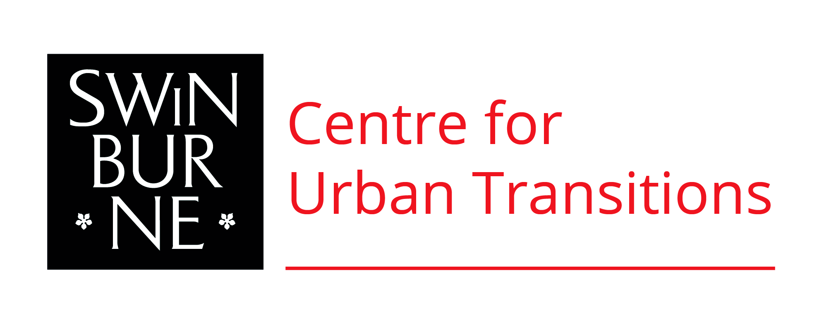

NATIONAL FORUM
Engaging Citizens in Transitions to Low-Carbon Living
Date | 24th November 2017
Time | 9.00 – 16.30
Venue | Engineers Australia, 600 Bourke Street, Melbourne
Objectives | We have the technology & expertise available to achieve significant reductions in greenhouse gas emissions from the built environment. However, issues such as perceived lack of demand for low carbon solutions, lack of public and business awareness of potential benefits, and a disorganized evidence-base are impeding the implementation of low-carbon solutions. How can policy makers overcome such barriers and more effectively engage citizens in transitions to low-carbon and sustainable urban living?  This forum will present the latest research and tools from the CRC-LCL, partners and collaborators that address these issues. It will provide an interactive discussion about new opportunities for businesses, communities and individuals to be engaged and empowered to transition to low-carbon behaviours and practices. It will offer policy makers insights into goals and governance, community engagement, media and technology, and the evidence, education and innovation opportunities for supporting the urban transitions necessary to achieve our climate and sustainable development goals.  The insights and ideas shared and generated at this forum will be documented and developed into a discussion paper for policy makers on recommendations for better engaging citizens in transitions to low carbon living.
Audience | CRCLCL project members, industry partners, policy maker, government
PROGRAM

Time | Welcome
09.00 | Registration (tea, coffee and sweet snacks will be provided on arrival)
09.30 | Welcome and Acknowledgement of traditional owners – Professor Peter Graham, CRC-LCL Node Leader Smart-Low Carbon Cities
09.40 | Introduction first Panel by Facilitator Tanya Ha
09.45 | Panel 1: The ‘Climate Friendly Citizen’  Can we Influence Behaviour and Social Practice to Live More Sustainably in Cities?
Prof. Aleks Subic
DVC Research
Swinburne University of Technology
Prof. Jane Farmer
Director
Swinburne Institute for Social Innovation
Prof. Peter Newton  Project Leader  Research Leader ‘Low Carbon Precincts’  Centre for Urban Transition  Swinburne University of Technology |  | Attitude-Action Gaps and the Prospect of Behaviour Change
Leonie Walsh
Former Victorian Chief Scientist
Hon Robert Hill AC  Chairman of CRC for Low Carbon Living |  | Policy, the market, innovation? What helps Australian’s become more climate friendly?
Dr. Vivienne Waller  Project Leader  Centre for Urban Transition  Swinburne University of Technology |  | RP2019 – Carbon Reductions from Composting Food Waste for Food Production  Fitting Recycling Models to Urban Forms
Dr. Yoshi Kashima  School of Psychological Sciences University of Melbourne |  | RP3012 – Environmental Attitudes – Low Carbon Behavioural Practice  Transformation to Low Carbon Living: Social Psychology of Low Carbon Behavioural Practice
11.00 | Panel 2: Evidence, Education & Innovation  How Do we Learn and Share Knowledge on Low-Carbon Urban Living in Ways that Support and Influence Big Decisions and Innovation?
Dr. Vanessa Rauland  Project Coordinator ‘Decarbonising Cities and Regions’  Curtin University Sustainability Policy Institute |  | RP3020 – Influencing change through a low carbon schools community program  Scaling up Peer to Peer School Community Group  Encouragement
Mark Eckermann  Product Innovation Manager S3MIT  Bluescope Australia and New Zealand |  | RP1037 – Making an evidence-based case to potential customers: Driving Increased Utilisation of Cool Roofs on Large Footprint Buildings  Making an Evidence-Based Case to Potential Customers
Cecille Weldon  Director, Weldonco |  | Influence through Language (for Real Estate Agents and other Professionals)
Amanda Lawrence  Analysis & Policy Obersvatory (APO)  Swinburne University of Technology |  | The Low Carbon Living Knowledge Hub – The Evidence-Base for Low-Carbon Policies and Practices
Kriston Symons AECOM  End Market Director  Buildings & Places, Australia and New Zealand |  | RP1009 - Closing the Loop Project
Dr. Stephen Glackin  Centre of Urban Transitions  Swinburne University of Technology |  | Greening the Grey Fields – Co-Development & Precinct Information Modelling
12.30 | Lunch
13.30 | Panel 3: Media & Technology  How can we Harness the Influence of Traditional and Social Media, and the ‘Internet of the Things’ to Facilitate Sustainable Urban Transitions?
Dr. Josh Byrne  Josh Byrne & Associates  Curtin University CUSP |  | RP3009 – High Performance Housing – Monitoring, Evaluating and Communicating the Journey  Media Impact and Engagement with Sustainable Housing
Prof. Kath Hulse  Director  Centre of Urban Transitions  Swinburne University of Technology |  | RP3021 – Media and Communication Strategies to Achieve Carbon Reduction Through Renovation of Australia’s Existing Housing  Media Mapping and Digital Media Strategies
Prof. Mark Burry  Director  Swinburne Smart Cities Research Institute |  | Learning from Barcelona – The Smart Citizen
John Gardner  Team Leader  Consumers and Resource Use –  AUSS, Land and Water CSIRO |  | RP3016 – The EnergyFit Homes Initiative: Empowering Consumers  RP3029 – Driving a National Social Media Conversation on Energy Efficient Housing  Quantitative Survey Work on People’s Attitudes to Sustainable Housing
Tina Perinotto  Managing Editor  The Fifth Estate |  | The impact of News Feeds
Prof. Hussein Dia  Swinburne Smart Cities Research Institute |  | Digital innovations and disruptive mobility – Mapping the value beyond the hype
14.45 | Panel 4: Goals & Governance  How do we Better Target Government Policies to Influence Citizens and what Behaviour Research could Help Mitigate the Climate Impacts of Cities?
Sandy Hollway
Deputy Chair – CRC for Low Carbon Living
Dr. Stephen White  Energy Efficiency Domain Leader,  CSIRO – Program Leader Engaged Communities |  | Built for Life
Jodie Pipkorn
Director, Residential Buildings Team
Department of the Environment and Energy
Australian Government
Kath Rowley
Executive Director, Climate Change Division,
Department of Environment, Land, Water and Planning
State Government of Victoria
Stephanie Ziersch  CEO – Stakeholder Strategy & Coordination  Sustainability Victoria |  | Climate Change Social Research
Neal Lawson
Deputy CEO - Melbourne Metro Trains
16.00 | Prof. Peter Graham – Recap: Key Points from each Panel Session
16.15 | Discussion & Next Steps
16.30 | Meeting Close

